
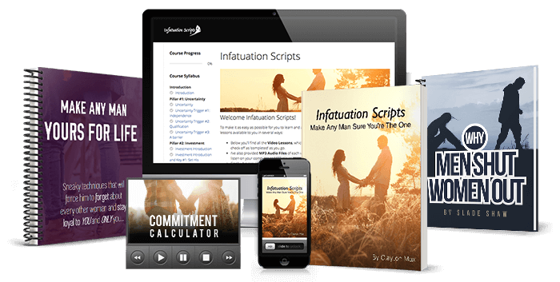
Infatuation Scripts Affiliate Pack
Make Him Sure
By Clayton Max
Links, angles, email swipes and social posts, ready to use

The offer and what you earn
Infatuation Scripts, by dating and relationship coach Clayton Max, shows women what to say so a man becomes sure she is the one. The tagline says it plainly: Make Any Man Sure You're The One.
Price | $49.95, one payment
Guarantee | 60-day money-back guarantee, no questions asked
What the buyer gets | Video, audio and e-book
Bonuses | The Commitment Calculator; Make Any Man Yours For Life; Why Men Shut Women Out (by Slade Shaw)

Your commission
Front end | 75%
Backend | 75%
Recurring | 35%
Upsell | About 65% of buyers take the upsell.
Refunds | The refund rate is under 6%.
Payments | ClickBank tracks the sales and pays you.

What is in the package
The program comes as video, audio and e-book. Its three bonuses are The Commitment Calculator, Make Any Man Yours For Life, and Why Men Shut Women Out by Slade Shaw.
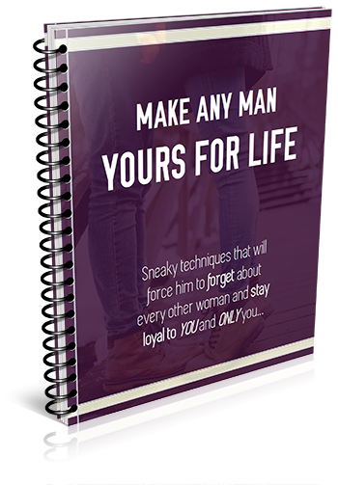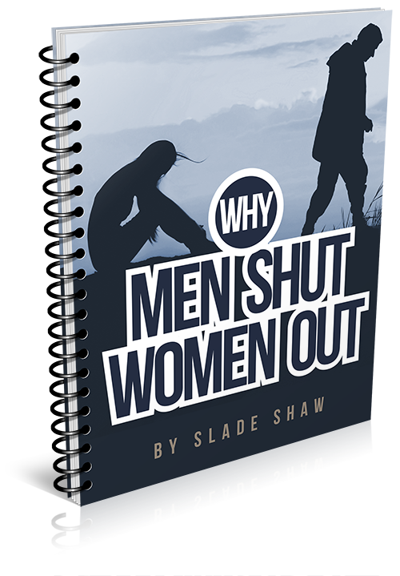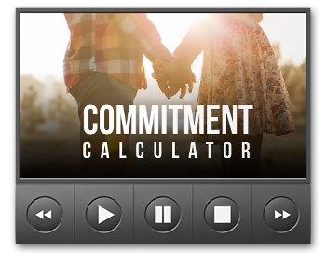

Your links
Every sale is credited to you through your ClickBank hoplink. This is the pattern:
https://hop.clickbank.net/?affiliate=YOUR-ID&vendor=claytonmax&tid=YOUR-TRACKING-ID

Swap YOUR-ID for your ClickBank nickname. The vendor is always claytonmax. To choose where your visitor lands, add one of these to the end of your link:
Add | Where it sends them
(nothing added) | Main video sales page. Best for most traffic.
&pg=written | Written sales letter (the Salescopy Page). Best for readers: blogs, articles and long emails.
&pg=order | Goes straight to the order page. Use it only for people who have already seen the video or the letter.
&pg=pay1 | ClickBank payment page (non-recurring product). Not recommended for email traffic. Recommended for paid traffic.
&pg=pay4 | ClickBank payment page (recurring product). Not recommended for paid traffic. Recommended for email traffic.

Tracking with tid.
The tid part is your own label, so ClickBank can show you which link made each sale. Use a different tid for each place you promote, for example email1, fb-post or blog. After a week you will know which one is working, and you can do more of it.

Link maker.
Put your ID in the link maker at https://aff.makehimsure.com/links/ and the swipes on the site will carry your link.

In this pack, YOUR-HOPLINK means your full hoplink, with your own ID and tracking ID.

Best angles
Pick one angle per email, post or video. A single clear idea gets more clicks than a mix of all of them. Each opening line is written to make the reader want the answer, so leave the answer to the video or the letter. There are ten angles on the site; these five are the strongest starting points.

1. He's pulling away
Who it suits: Women dating someone who has started to go quiet: slower replies, fewer plans, less attention than at the start.
The idea: The letter opens with Emma at a restaurant, feeling the man she likes losing interest before dessert. She uses a curiosity script, then an investment script and an uncertainty script, and by the end of the night he is holding her hand. The idea underneath: reasoning with him or showing him how great you are won't bring him back, but waking up his infatuation instinct will.
Opening lines you can use:
- Halfway through dinner she could feel him losing interest, and she had until dessert to change his mind.
- He used to reply in minutes, and now it takes him a day. What you say in your next conversation matters more than anything you said before.
- When a man starts to drift, being nicer to him is the reflex. Watch what happened when one woman said something very different.
Send the link to: the main video page, no pg= needed.

2. The "what are we?" talk
Who it suits: Women a few weeks or months in with no label yet, waiting for him to say where it is going.
The idea: In the letter, Emma never has to ask. Jack is the one who brings up the "so where is this going?" talk, because he is the one who is hooked. Investment scripts get a man working to earn your attention, and the more he puts in, the deeper he falls.
Opening lines you can use:
- What if he was the one asking "so where is this going?"
- Before you ask him "what are we?", watch what happened when a woman waited for him to bring it up.
- Some men rush to make it official, and others dodge the question for months. The difference starts with what she says.
Send the link to: the main video page, no pg= needed.

3. Long-term, but he's stopped trying
Who it suits: Women with a long-term boyfriend or husband who has become comfortable and stopped making an effort, or who still changes the subject when the future comes up.
The idea: The letter says that when a man feels he has complete control of a woman and the relationship, the excitement goes and his infatuation instinct gets stuck in the off position. The scripts are made to put him back into courtship mode, so he realises how lucky he is to have you and starts showing it.
Opening lines you can use:
- He used to plan dates and bring you flowers. Then he got comfortable.
- If you have been together for years and he still changes the subject when the future comes up, there is a reason, and it can be changed.
- The man who couldn't wait to see you at the start is still in there.
Send the link to: the main video page, no pg= needed.

4. The checklist trap
Who it suits: Women who have worked hard to be what men say they want (kind, fun, smart, easy-going) and still end up "almost" chosen.
The idea: Most women try to be a man's perfect girl and tick every box on his list. The letter explains that this only reaches the rational part of his brain. It doesn't touch the infatuation instinct, which is what overrides all his reasons to hold back and makes him certain.
Opening lines you can use:
- You can be everything on his list, and he can still feel that something is missing.
- Men say they want smart, funny and kind. Then they fall for a woman who doesn't fit the list at all.
- Trying to be his perfect girl speaks to the wrong part of his brain.
Send the link to: the written letter, add &pg=written.

5. Why he left his "perfect girl"
Who it suits: Women who have been let go by a man who said they were wonderful, and never got a real reason.
The idea: This is Emma's own story. Liam told her she was everything he had ever wanted, but something was missing. Months later he got engaged to Stephanie, and told Emma he had never felt so sure. Her search for why led her to Clayton Max and the infatuation instinct. The story reads well as text, so the written letter suits this angle.
Opening lines you can use:
- "You're everything I've always wanted. But something's missing." Six months in, that's what he told her.
- He said she was perfect for him. A few months later he called to say he was engaged to someone else.
- She begged him to tell her what was missing, and he couldn't give her an answer.
Send the link to: the written letter, add &pg=written.

Email swipes
Eight emails, ready to send. Replace YOUR-HOPLINK with your hoplink, change {first_name} to your email service's first-name tag (or delete it), and keep the disclosure line at the bottom. Only email people who asked to hear from you, and follow CAN-SPAM and your country's email rules. Emails 1 to 3 come from a five-day launch series, so you can send them a day apart. All twenty swipes are at https://aff.makehimsure.com/emails/

Email 1: Day 1: "Everything I want, but something's missing"
Subject line options (pick one)
- He said I was everything he wanted. Then he left.
- When he says "something's missing"
- Why he keeps one foot out the door
Preview text: It has nothing to do with how good you are for him on paper.
Hi {first_name},
Have you ever been with a man who said all the right things about you, and still seemed to have one foot out the door?
He tells you you're smart, funny and beautiful. He laughs at your jokes. But when the talk turns to where this is going, he goes quiet, or he says the timing isn't right.
I watched a video this week that explains why this happens, and it changed how I think about it.
The woman telling the story is called Emma. Six months into dating a man she adored, he took her for a walk and told her she was everything he'd always wanted in a woman, but something was missing, and he just had a feeling she wasn't the one.
She begged him to tell her what was missing. He couldn't.
A few months later he called her late one night to tell her he was engaged to someone else, a woman he'd described to Emma as "just a friend" only weeks before.
The video goes into what that other woman did that Emma hadn't done, and it's got nothing to do with being prettier or more patient.
You can watch it here:
YOUR-HOPLINK
Talk soon,
P.S. Tomorrow I'll tell you about the dating coach who worked out what was going on, after three of his friends who swore they'd never settle down all got engaged in the same year.
I may earn a commission if you buy through my link.

Email 2: Day 2: Three friends who said they'd never marry
Subject line options (pick one)
- 3 men who swore off marriage, 3 engagements
- What these women did differently
- He said "never", then couldn't wait to marry her
Preview text: None of the women had the qualities those men said they wanted.
Hi {first_name},
Yesterday I told you about Emma, whose boyfriend said she was everything he wanted and then got engaged to someone else.
Emma is a journalist, and after that phone call she set out to find out why some women make men so sure, while others leave men hesitating for years. The experts she interviewed talked about communication and loving yourself first, which is good advice, but none of them could tell her why a man suddenly becomes certain about one woman.
Then she met Clayton Max, a dating and relationship coach with a background in applied psychology.
Clayton had been puzzling over the same question. In one year, three of his friends got engaged. These were men who had spent years saying marriage wasn't for them, and suddenly they couldn't wait to spend their lives with one woman. One of them even moved across the country to make it work.
What struck Clayton was that the women these men fell for didn't have most of the qualities the men had always said they were looking for.
So he interviewed the couples and spent months going through the research on love and attraction, until he found what those women had done differently.
He calls it the Infatuation Instinct, and the video explains it far better than I can in an email.
Watch it here:
YOUR-HOPLINK
Talk soon,
P.S. Tomorrow I'll tell you what actually happens in a man's head when that instinct switches on, and why it makes his "I'm not ready" excuses disappear.
I may earn a commission if you buy through my link.

Email 3: Day 5: What's inside, the price and the guarantee
Subject line options (pick one)
- What's inside Infatuation Scripts
- $49.95, and 60 days to decide
- Everything in one place
Preview text: The scripts, three bonuses and 60 days to make up your mind.
Hi {first_name},
This is the last email in this little series, so here's everything in one place.
Infatuation Scripts is Clayton Max's program for making a man sure you're the one. You can use it with a man you've just met, with someone you've just started dating, or with your long-term boyfriend or husband, so he sees how lucky he is to have you.
Inside are scripts for each of the triggers that switch on a man's Infatuation Instinct, including:
- Intrigue scripts, which get his attention and keep you on his mind
- Cliffhanger scripts for the end of a conversation, so he feels he has to see you again
- Barrier scripts, which let you show how much you like him without handing him control of the relationship
- Urgency scripts, which give him the feeling he needs to act now or risk losing you
You also get three bonuses: The Commitment Calculator, Make Any Man Yours For Life by Amy North, and Why Men Shut Women Out by Slade Shaw, which is built on an anonymous survey of over 700 men.
It comes as video, audio and e-book, so you can go through it on whichever device suits you. The price is a one-time payment of $49.95.
It also has a 60-day, no-questions-asked money-back guarantee. You can go through all of it and try the scripts, and if you're not happy for any reason, you ask for a refund within the 60 days.
Here's the link:
YOUR-HOPLINK
Talk soon,
P.S. Watch the video first. If what Emma says about her ex sounds familiar, you'll know straight away whether this is for you.
I may earn a commission if you buy through my link.

Email 4: While you wait for his text (the Infatuation Instinct)
Subject line options (pick one)
- While you're waiting for his text
- Tap into a man's infatuation instinct
- Flip a man into infatuation mode
Preview text: There's a reason some men can't stop thinking about one woman.
Hi {first_name},
There are few things more painful than obsessing over a man who isn't thinking about you at all.
You can't get him out of your head. You check your phone every few minutes, waiting for him to reply, and when he does, you read his text over and over, looking for clues in every word and every full stop.
And all the while he's carrying on with his day as if nothing has happened.
The good news is that you can do something about this.
Dating coach Clayton Max has built a program around an "emotional tripwire" in the male brain, drawing on research from Rutgers University, SUNY Stony Brook and the Albert Einstein College of Medicine. When it's set off, it flips a man into what Clayton calls infatuation mode, where he can't stop thinking about you and becomes sure you're the one he wants.
Discover how to flip a man into infatuation mode here:
YOUR-HOPLINK
Clayton calls it the Infatuation Instinct, and it exists to overcome a man's natural reluctance to settle down with one woman. It makes him idealise you, so he sees your best qualities first and his doubts and hesitations fade away.
In the video you'll hear from Emma, who had been passed over by man after man without ever knowing why, and what she said to a man at dinner that turned his feelings around before the bill arrived.
If you've ever been passed over by a man who couldn't see everything you had to offer, you're going to learn a lot from it.
Watch it here:
YOUR-HOPLINK
Talk soon,
I may earn a commission if you buy through my link.

Email 5: Why men push away their "perfect girl"
Subject line options (pick one)
- Why men push away their "perfect girl"
- Why he chose someone who made no sense for him
- "Why wasn't I enough for him?"
Preview text: Being everything he says he wants isn't what makes him sure.
Hi {first_name},
When you meet a man you're really into, it's easy to fall into the trap of trying to be his dream girl.
You show him all your best girlfriend qualities. You listen, you're loyal, you put him first and you're there whenever he needs you, in the hope that if you tick every box on his list, you'll be his natural choice.
The problem is that this almost never works.
So many women end up hurt and confused when he chooses someone who has hardly any of the qualities he said he wanted.
Men like to think of themselves as logical, but they don't choose the woman who is the best logical choice for them. They choose the woman who makes them feel a certain way, and more exactly, the woman who sets off feelings of infatuation in them.
Get the exact scripts that make a man feel infatuated with you here:
YOUR-HOPLINK
Dating coach Clayton Max calls this the Infatuation Instinct. When it's triggered, it releases powerful emotions in a man, pushes aside the "rational" objections he had to being with you and wipes out his doubts, so he's sure you're the one he wants.
When a man has to choose between a woman who makes sense for him and one who has set off his Infatuation Instinct, he picks the second one every time.
So if you've been hoping a man will choose you because you're good for him, it's time to change your approach.
Watch the video and learn what to say to trigger the Infatuation Instinct in a man:
YOUR-HOPLINK
Talk soon,
I may earn a commission if you buy through my link.

Email 6: For readers who have just met someone
Subject line options (pick one)
- Just met someone you like?
- How to stand out to a man you've just met
- Read this before your next first date
Preview text: The first few conversations decide more than most of us realise.
Hi {first_name},
If you've just met a man you like, this one's for you.
The first few conversations are when a man decides, often without noticing, whether you're someone he'll keep thinking about or someone he'll quietly forget. Most of us spend those conversations trying to make a good impression by being agreeable, laughing at his jokes and showing him how easy we are to be around.
That's lovely, but it rarely makes you stand out from every other woman he talks to.
Dating coach Clayton Max has written what he calls Intrigue Scripts and Cliffhanger Scripts for exactly this stage. Intrigue scripts catch a man's attention and make him curious about you, so you stay on his mind after you've said goodnight. Cliffhanger scripts are for the end of a conversation or a date, and they leave him feeling not quite satisfied, with a strong pull to see you again.
There's also an "interested but not sold" script, which lets a man know he has a chance with you but that he'll have to work to win you over. Clayton says most men are so unused to a woman with that attitude that this script on its own can send them into full infatuation.
Watch the free video that explains how it all works:
YOUR-HOPLINK
Talk soon,
I may earn a commission if you buy through my link.

Email 7: For readers stuck at "what are we?"
Subject line options (pick one)
- "So... what are we?"
- Dating for months, and still no label?
- What if he brought up the relationship talk?
Preview text: Imagine him being the one who asks where this is going.
Hi {first_name},
You've been seeing him for a while. You talk most days, he seems to really like you, and you can picture a future with him.
But you don't know what you are to each other, and every time you think about asking, you worry that bringing it up will scare him off.
Emma, the woman who tells her story in the video I'm sending you to, used to feel this way with man after man. What changed it for her was what she learned from dating coach Clayton Max. Once she started using his scripts with Jack, the man she was seeing, it was Jack who brought up the "so where is this going?" conversation, because he was the one eager to move things forward.
Clayton's program, Infatuation Scripts, has scripts for this stage too. Shaping scripts and investment scripts encourage a man to put more and more effort into winning you, and the more he puts in, the deeper his feelings for you grow. Urgency scripts give him the feeling that if he doesn't act soon, he might lose you.
Watch the video here:
YOUR-HOPLINK
Talk soon,
I may earn a commission if you buy through my link.

Email 8: For readers in a long-term relationship or marriage
Subject line options (pick one)
- When he's stopped noticing you
- The way he used to look at you
- For anyone who's been together a while
Preview text: Infatuation isn't only for the first few dates.
Hi {first_name},
When you've been together a long time, it's easy to slip into a routine. He's a good man and you love each other, but somewhere along the way he stopped planning dates and noticing the little things, and started taking you a bit for granted.
Most advice about infatuation is aimed at women who are single or just starting to date. Infatuation Scripts, by dating coach Clayton Max, is written for women in long-term relationships and marriages as well.
In the video you'll hear about Beth-Ann, one of Clayton's students, who had been married for 23 years. She used his investment scripts to put her husband back into what Clayton calls courtship mode. He became aware again of how lucky he was to have her, started bringing her flowers and planning dates for the two of them, and told her every day how much she meant to him.
That's the aim of the program for couples: a man who already loves you seeing you as the centre of his world again.
Watch the video here:
YOUR-HOPLINK
Talk soon,
P.S. One of the bonuses that comes with it, Make Any Man Yours For Life by Amy North, goes through the reasons men cheat and the steps that help prevent it, which is worth having in any long relationship.
I may earn a commission if you buy through my link.

Social posts
Some platforms limit or hide posts with direct affiliate links. The safest route is to put your hoplink in your bio link, or send people to your own page first, and say "link in bio" in the post. Use each platform's paid partnership label where it has one, and keep the disclosure near the top or next to the link. Pictures to post with these are at https://aff.makehimsure.com/social/

What she said before dessert (angle: He's pulling away)
Emma was sitting across from a man she really liked, and she could feel him drifting. He looked bored and kept glancing around the restaurant, and she was sure that if nothing changed before dessert she would never hear from him again.
So she took a deep breath and said something she would never have dreamed of saying a week earlier. By the time the bill came, he was holding her hand.
She explains exactly what she said, and why it works on the part of a man's brain that decides who he is sure about, in this free video:
YOUR-HOPLINK
I may earn a commission if you buy through my link.
#datingadvice #datingtips #relationshipadvice #datingadviceforwomen #lovelife #relationshiptips

Perfect on paper (angle: Why he left his 'perfect girl')
"You're beautiful, you're kind, you're smart and fun. You're everything I've always wanted. But something's missing."
That is what Emma's boyfriend told her six months in. A few months later he called to say he was engaged to someone else, and that he had never felt so sure of anything.
If you have ever been the woman who ticked every box and still wasn't chosen, this video will make sense of it. Being even more perfect for him was never going to fix it, because there is a part of a man's brain that his checklist never reaches.
Watch the free video here: YOUR-HOPLINK
I may earn a commission if you buy through my link.
#datingadvice #relationshipadvice #heartbreak #datingtips #womensupportingwomen #lovelife

The message that never comes (angle: Newly dating)
He said he would message after your date. Now it's Tuesday, and you have checked your phone more times than you would like to admit.
Most dating advice talks about communication, compromise and loving yourself first. All good things, but none of them explain why some men can't stop thinking about one woman while others drift off without a word.
Clayton Max, a dating and relationship coach with a background in applied psychology, spent months finding out what happens in a man's head when one woman becomes the only one he wants. His free video is worth watching before you send that next text: YOUR-HOPLINK
I may earn a commission if you buy through my link.
#datingadvice #datingtips #textingtips #datingadviceforwomen #singlelife #relationshipadvice

Engaged to someone else (angle: Why he left his 'perfect girl')
#ad He told her she was everything he had ever wanted, and then said something was missing. A few months later he was engaged to someone else. This free video explains what the other woman did differently: YOUR-HOPLINK

More to promote with
Everything below is on the affiliate area, free for you to use. Your saved hoplink is already inside the codes and swipes.
Resource and address | What you will find
Banners  https://aff.makehimsure.com/banners/ | Three new banner sets in every standard ad size, plus square and link-post sizes for social media, with your hoplink already in the code.
Presell pages  https://aff.makehimsure.com/landing/ | Landing page templates you can put on your own site and send your traffic through.
Articles  https://aff.makehimsure.com/articles/ | Ready-to-publish articles for your blog, newsletter or Facebook page, with title options and a disclosure line.
Paid traffic keywords  https://aff.makehimsure.com/keywords/ | Keyword sets for paid traffic, blog posts and YouTube videos. Read the rules at the end of this pack before you run any ads.
Hooks and angles  https://aff.makehimsure.com/hooks/ | Ten angles with opening lines you can use as subject lines, post openers or the first line of a video.
Emails  https://aff.makehimsure.com/emails/ | All twenty email swipes, ready to send with your saved hoplink.
Social posts and images  https://aff.makehimsure.com/social/ | Captions, short posts and pins, each with a picture you can post with it.

Rules and disclosure

Promotion rules
- Google and Bing Advertising. Affiliates will need to undergo a review before you can promote Make Him Sure on Google and Bing. See the Google and Bing rules below.
- Do Not do Brand Marketing. Affiliates are not allowed to bid any brand keywords like “Make Him Sure”.
- Do Not Use False Representation. As an affiliate, you are not allowed to falsely promote yourself as the owner or creator of Make Him Sure.
- Do Not Use False Negative Marketing. You are not allowed to market using negative strategies. This includes using words like fraud or scam in your ads or in your copy.
- Do Not Spam Your Email Lists. Do not Spam your email lists when promoting any Make Him Sure and Make Him Sure products. Do not send unsolicited emails.
- Do Be Clear and Upfront. Make it clear to your list or your audience that you are being compensated to promote Make Him Sure products.
For more rules and best practices, see ClickBank's promotional guidelines: https://support.clickbank.com/en/articles/10535354-promotional-guidelines

If you advertise on Google and Bing
- Do Have Quality Websites. Affiliates are required to have quality websites. Do not just create a landing page, fill it with some of the free articles provided in the affiliates area. Instead, create original content and make your website valuable to your visitors. Make your website look good as well.
- Do Have Your Website Reviewed. Contact us via the Affiliates Page before you start a Bing or Google Ad Campaign. Your websites need to be reviewed to make sure that you are following the rules. We can also help you with tips on marketing and optimization during the review process.
- Do Not Do Brand Keyword Advertising. Affiliates are not allowed to bid any brand keywords like "Make Him Sure”, etc.
- Do Not Use Brand Words in Ad Copy. You are not allowed to use brand words in any copy. Do not list phrases like “Make Him Sure”, etc.
- Do Not Directly Advertise to Any Make Him Sure URLs. Affiliates are not allowed to directly advertise to Make Him Sure and Make Him Sure URLs.
- Do Not Use Direct Hoplink Advertisement. Do not advertise directly to a Hoplink URL. Use your own website instead. This is poor marketing practice and your ads are likely going to get denied.
- Do Follow Our Other Rules. For our other promotion rules. Please follow the general promotion rules above as well.
Disclosure line.
Use it on every swipe: "I may earn a commission if you buy through my link."

- Email: put the line near the link, and keep the one at the bottom of every swipe.
- Social posts: start with #ad, or use the platform's paid partnership label, and keep it next to the link, not buried in a pile of hashtags.
- Video: say it early in the video and write it in the description.
- Articles and pages: put it at the top and next to the first link.

Claims to avoid
- Do not promise results. Never say or imply that the program will make a man commit, propose or marry her.
- Do not invent testimonials, studies, statistics or earnings. Use only what is on the sales page and in these swipes.
- Do not change the price or the guarantee, and do not promise bonuses the program does not include.
- Do not call the program a fraud or a scam, and do not say you are the owner or creator.
- Keep the explanation of the scripts for the video or the letter. Your copy should make people curious, not give the answer away.
Results vary from person to person, and nobody can promise one.

Questions? Talk to me

Andrew Rusbatch
Affiliate Manager, Unica Publications
andrew@unicapublications.com
Write to Andrew about anything: a new angle you want to try, a site you want reviewed before you run Google or Bing ads, or a question about a link.
Your next steps
- Make your link at https://aff.makehimsure.com/links/ and add your own tid.
- Choose one angle and one email or post from this pack.
- Add the disclosure line and send it.

